Delft University of Technology

INSPECTION REPORT FOR DEVICES TO BE USED IN CONNECTION WITH HUMAN SUBJECT RESEARCH

This report should be completed for every experimental device that is to be used in interaction with humans and that is not CE certified or used in a setting where the CE certification no longer applies[1]. **The first part** of the report has to be completed by the **researcher and/or a responsible technician**. Then, the safety officer (AMA – Arbo en milieu adviseur) of the corresponding faculty has to inspect the device and fill in the second part of this form. Please visit <https://intranet.tudelft.nl/arbeidsomstandigheden/arbeidsomstandigheden/overzicht-amas/> for more information.

Note that in addition to this, all experiments that involve human subjects have to be approved by the Human Research Ethics Committee of TU Delft. You can find more information on the procedures at <http://www.hrec.tudelft.nl/>

**Device identification (name, location): Bicycle Mock up, Automotive area (next to the bike lab)**

**Configurations inspected[2]:**

**Type of experiment to be carried out on the device:[3]**

**Name(s) of applicants(s): George Dialynas, Arend Schwab & Riender Happee**

**Job title(s) of applicants(s): PhD researcher, Assistant & Associate Professors**

(Please note that the inspection report should be filled in by a TU Delft employee. In case of a BSc/MSc thesis project, the responsible supervisor has to fill in and sign the inspection report.)

**Date:**

07/06/2017

**Signature(s):**

**Setup description**

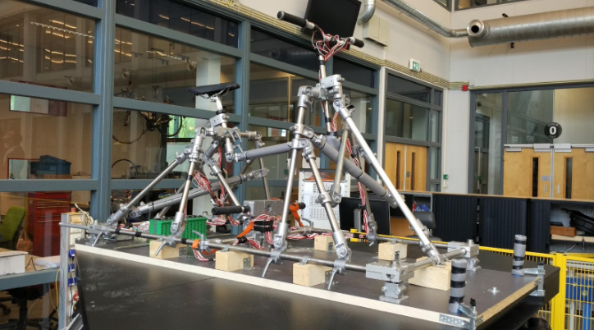

Fig.1 Bicycle mock-up

**Mechanical part of the setup**

The experimental setup mainly consist of two parts a bicycle mock up and a hexapod platform. The bicycle mock up represent the structure of a real bike. It is made from steel tubes and solid aluminum clamps. It has four major parts, the seat post assembly, the foot pegs assembly, the handlebar assembly and a wooden base.

The seat post and handlebar assembly consist of a structure capable of distributing the load to the base effectively. The foot pegs consist of a T-shape assembly. The mock up is fitted on a wooden base with the help of metal bases.

The whole structure is stiff, stable and has a certain degree of adjustability, not only in the height of the seat or handlebars but also in the position of the foot-pegs and the stack and reach dimensions.

**Electromechanical part of the setup**

The interaction points are instrumented with strain gauges, enabling us to measure the force exerted by the rider in each moment. In addition, the relative position of the rider’s trunk to the frame will be measured using an IMU system. Amplifiers and a data acquisition system from LabVIEW are also mounted at the back of the platform with metal stripes.

**Hexapod platform**

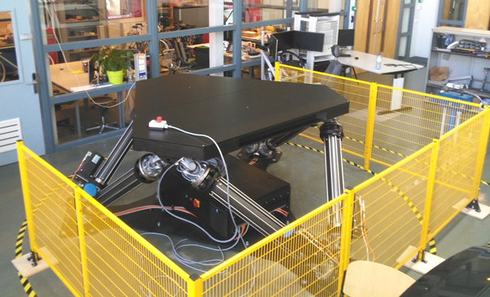

Fig.2 Hexapod platform

The Hexapod platform will be responsible for generating 3D motion perturbations in a frequency range of 0.5- 10 Hz. Amplitude and oscillation frequency are selected based on rider comfort . It should be mentioned that the operator can shut down the moving platform at any time with a safety switch.

**Hexapod+ Bicycle mock up**

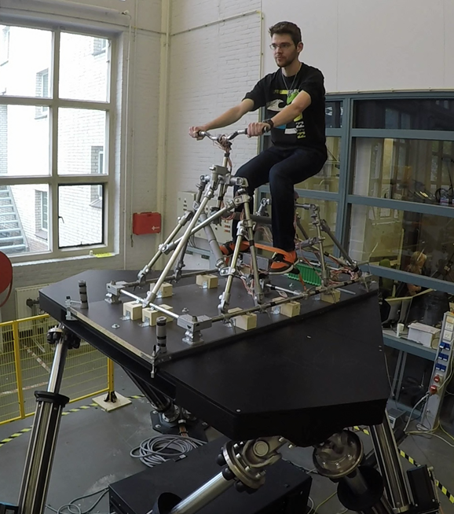

Fig.3 Bicycle mock up mounted on the top of the hexapod

As a final step the bicycle mock up fig1 is mounted on the top aluminum plate of the hexapod platform fig.2. This is achieved with 5 screws M12 6.6 distributed on the corners and middle section of the metal plate. Two clamps are also placed on the front as a second safety measure.

**Safety measures**

To avoid any accidents that might occur from loss of balance during the experiments. Two safety measures are in place. First measure is a stripe around his feet, and second measure is a safety harness around his upper torso. The military harness will be hanged from the sealing. In case the mock up fail the participant will hang freely from the sealing avoiding any injuries that might occur from falling. A similar harness as shown at figure 4 is in place.

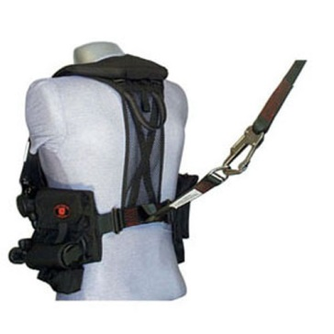

Fig.4 Military harness

**Risk checklist**

Please fill in the following checklist and consider these hazards that are typically present in many research setups. If a hazard is present, please describe how it is dealt with.

Also, mention any other hazards that are present.

|  |  |  |  |
| --- | --- | --- | --- |
| **Hazard type** | **Present** | **Hazard source** | **Mitigation measures** |
| Mechanical (sharp edges, moving equipment, etc.) | yes | Hexapod platform | A fence is placed around the platform. Only authorized people can pass during the experiments. A safety switch is located next to the operator |
| Electrical | yes | Strain gauges & wires | Wires& strain gauges are isolated |
| Structural failure | yes | Bicycle mock up | Structural tubes close to seat are covered with plastic ferrosol. In case of failure rider leg are protected. |
| Touch Temperature | no |  |  |
| Electromagnetic radiation | no |  |  |
| Ionizing radiation | no |  |  |
| (Near-)optical radiation (lasers, IR-, UV-, bright visible light sources) | no |  |  |
| Noise exposure | no |  |  |
| Materials (flammability, offgassing, etc.) | no |  |  |
| Chemical processes | no |  |  |
| Fall risk | yes | Hexapod platform | A military safety harness is used. Participant is hang through the sealing. Not possible to fall |
| *Other:* |  |  |  |
| *Other:* |  |  |  |
| *Other:* |  |  |  |

**Appendices**

Manuals and CaD of the Mock up can be found here:

<https://drive.google.com/open?id=0B2FwvRQEH_OxN2pKSW9CSFhSeWc>

**Device inspection**(to be filled in by the AMA advisor of the corresponding faculty)

**Name:**

**Faculty:**

The device and its surroundings described above have been inspected. During this inspection I could not detect any extraordinary risks.

*(Briefly describe what components have been inspected and to what extent (i.e. visually, mechanical testing, measurements for electrical safety etc.)*

**Date:**

**Signature:**

Inspection valid until[4]:

Note: changes to the device or set-up, or use of the device for an experiment type that it was not inspected for require a renewed inspection

1. Modified, altered, used for a purpose not reasonably foreseen in the CE certification
2. If the devices can be used in multiple configurations, otherwise insert NA
3. e.g. driving, flying, VR navigation, physical exercise, ...
4. Indicate validity of the inspection, with a maximum of 3 years